Practice Problems Section 16 Solutions

1. An object is placed 14 cm from a spherical, concave mirror. A real image is formed at a distance of 14 cm from the lens. I now move the object to a distance of 28 cm from the mirror and get a new image.
2. How far from the mirror does the new image appear? On what side of the mirror does it appear (same or opposite side as the object)? **Show your work!**

First, we use the information given to find the focal length of the mirror. We note that since a real image is formed, $s^{'}>0$.

$$\frac{1}{14}+\frac{1}{14}=\frac{1}{f}→f=7 \text{cm}$$

Now that we have the focal length, we can find the new image.

$$\frac{1}{28}+\frac{1}{s'}=\frac{1}{7}→s^{'}=\frac{28}{3}\text{ cm}=9.33 \text{cm}$$

**Thus, the image appears 9.33 cm from the mirror, and since the image distance is positive, it is a real image, thus it appears on the same side of the mirror as the object.**

1. What is the magnification of the new image? Is it erect or inverted? **Show your work!**

$$m=-\frac{s^{'}}{s}=-\frac{\left(\frac{28}{3}\right)}{28}=-\frac{1}{3}$$

**Thus, the image is 1/3 the size of the object, and since $m<0$ the image is inverted.**

Spherical $\text{Mirrors: }f=\frac{R}{2}$ $\frac{1}{s}+\frac{1}{s'}=\frac{1}{f}$ $m=-\frac{s'}{s}$

1. A diverging lens has a focal length of 15 cm. I place a 10 cm tall object a distance of 8 cm from the lens.
2. Complete a ray tracing sketch to show the approximate location and magnification of the image.

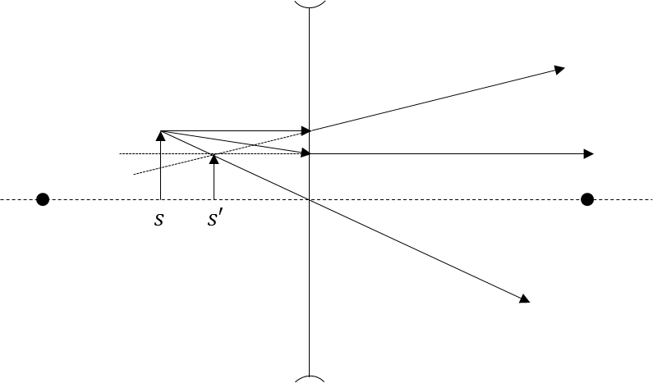

1. Calculate exactly the location of the image relative to the lens. **Show your work!**

$$\frac{1}{8}+\frac{1}{s'}=\frac{1}{-15}→s^{'}=-5.22\text{ cm}$$

**The image is 5.22 cm from the lens, on the same side of the lens as the object.**

1. Calculate exactly the height of the image. **Show your work!**

$$m=-\frac{s^{'}}{s}=-\frac{\left(-5.22\right)}{8}=.6525$$

$$y^{'}=my=.6525*10=6.525 \text{cm}$$

**The image is 6.525 cm tall and has the same orientation as the object.**

$\text{Thin Lenses: }\frac{1}{f}=\left(n-1\right)\left(\frac{1}{R_{1}}-\frac{1}{R_{2}}\right)$ $\frac{1}{s}+\frac{1}{s'}=\frac{1}{f}$ $m=-\frac{s'}{s}$